**‘AccessBank DBA Internship Program’**

**Project 8: Creating SQL logins and securing the database**

Creating SQL logins and applying permission to the database and its objects (tables) to various SQL logins and Windows users.

The IT director has asked you to do the following:

* Set the authentication mode from Windows to mixed mode
* Script out and create 2 new SQL Logins for users Rashad and Nadir
* Map the 2 new SQL logins to the Adventureworks2014 database
* Give them both select permissions to the tables HumanResources.Department and HumanResources.Employee only

1. **I have set the authentication mode from Windows to mixed mode and then restarted SQL Server Service to make changes take affect:**

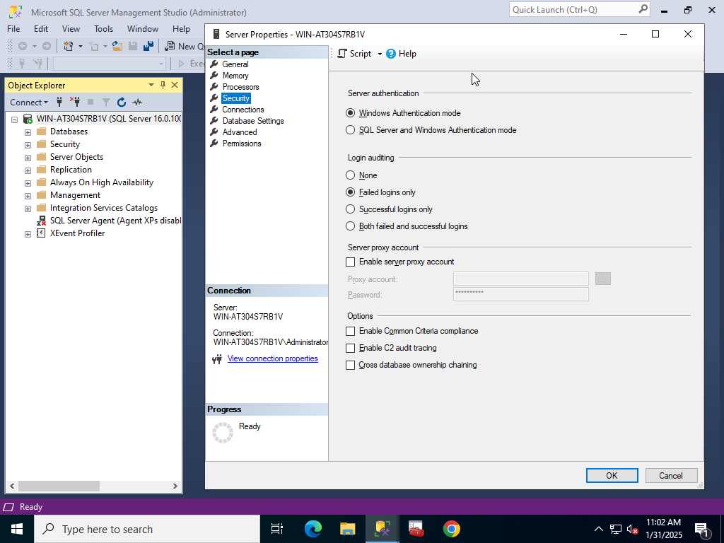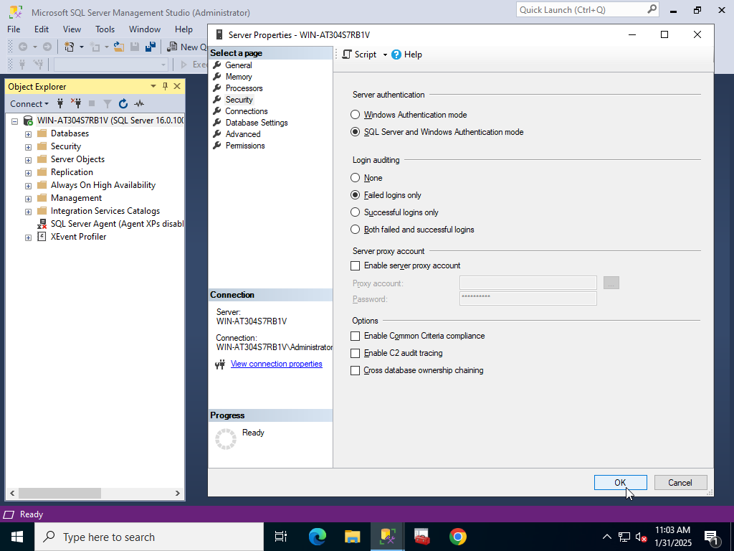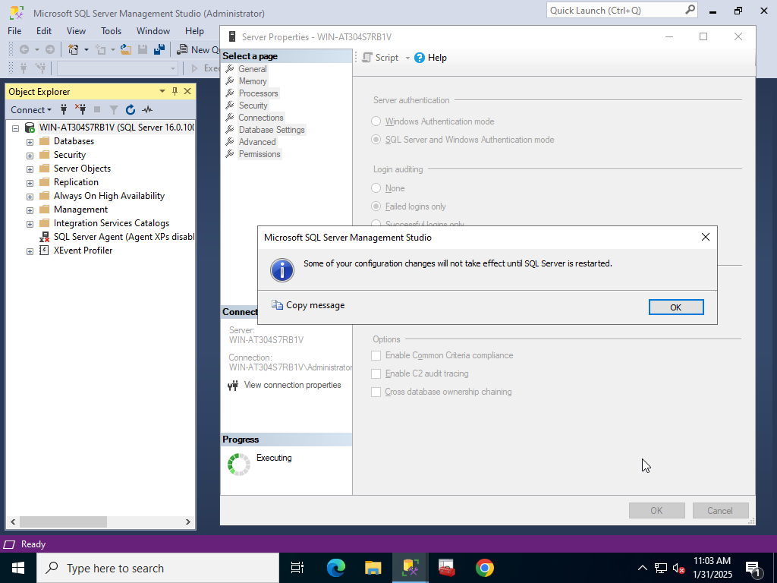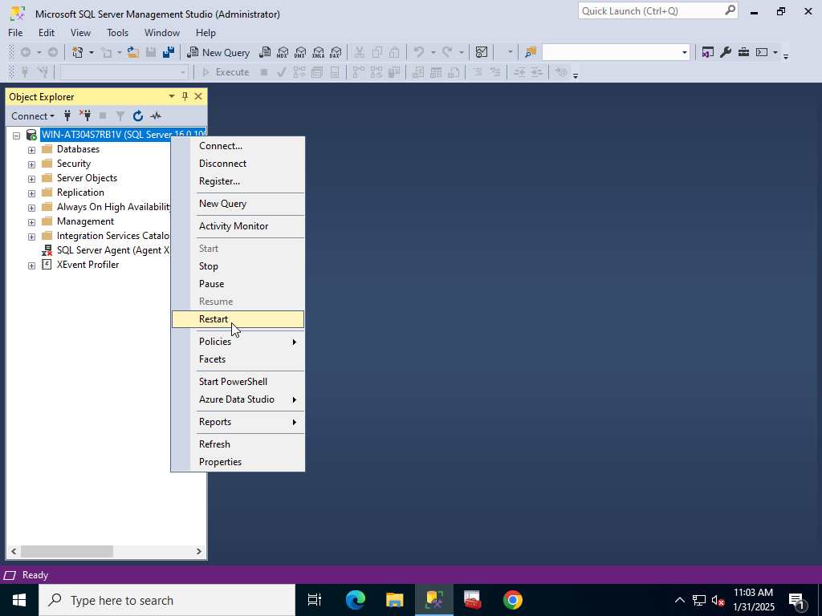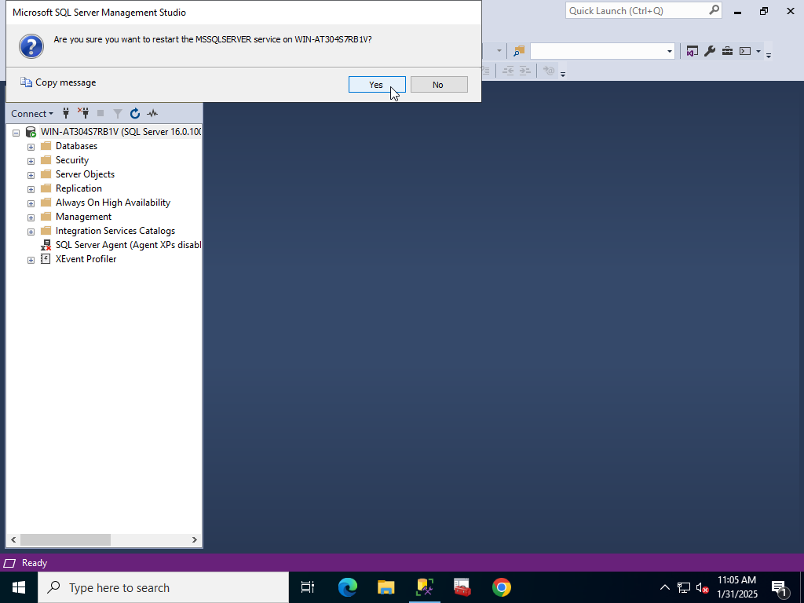

**2) Then I created 2 SQL logins for Rashad and Nadir by using T-SQL statements and executed that script and refreshed Logins to make sure whether both of them has been created or not:**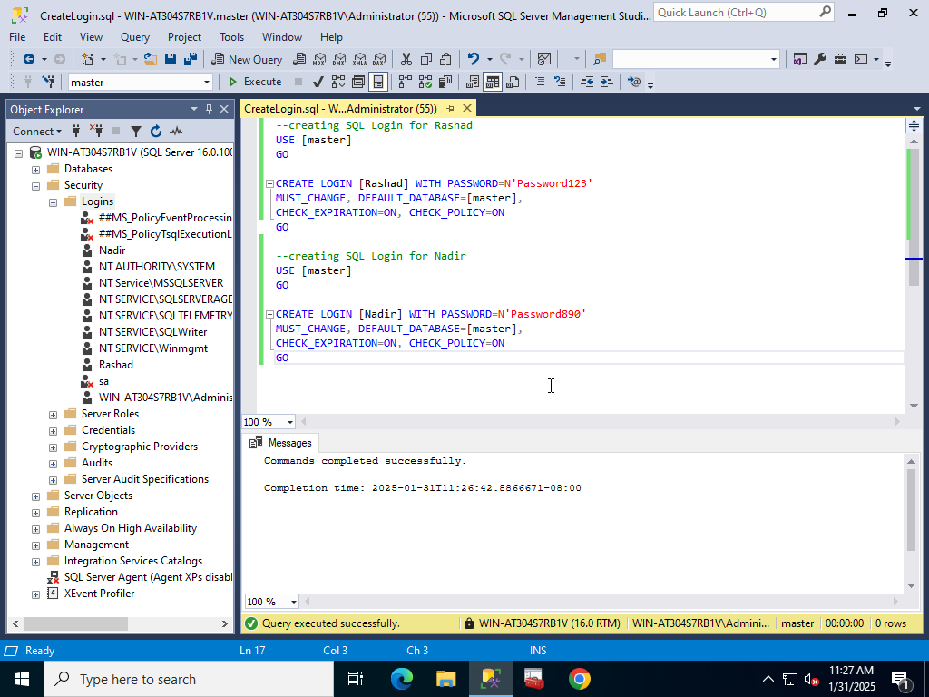

**3) Then I created 2 SQL User for each of them according to their SQL logins in order to see databases:**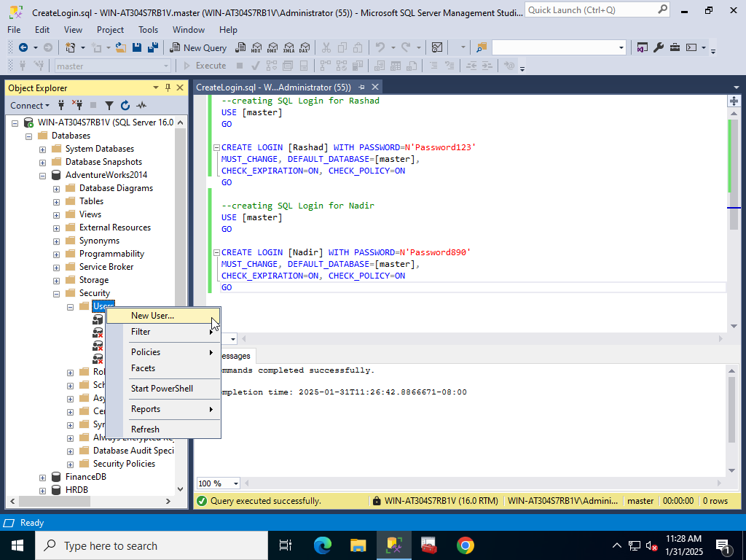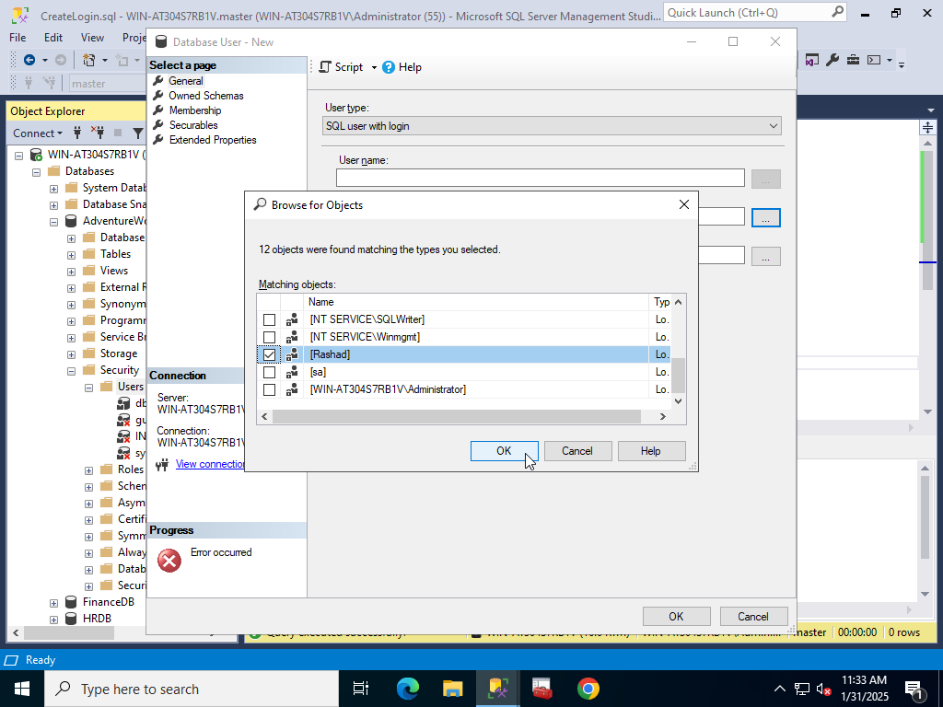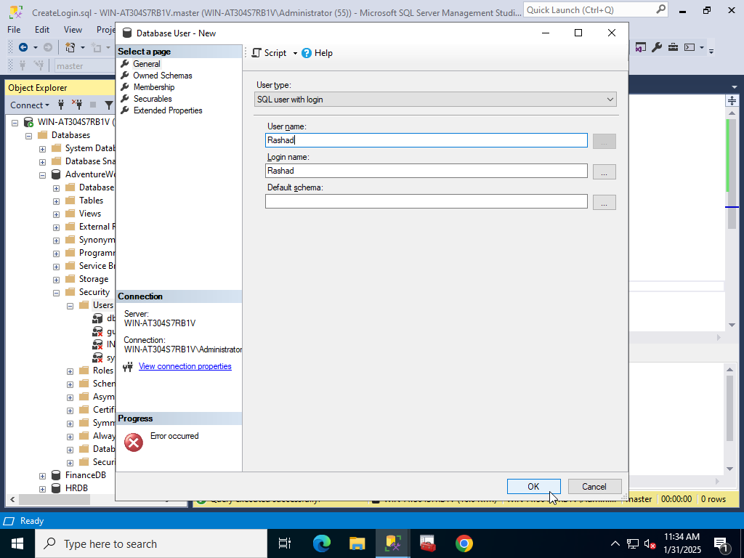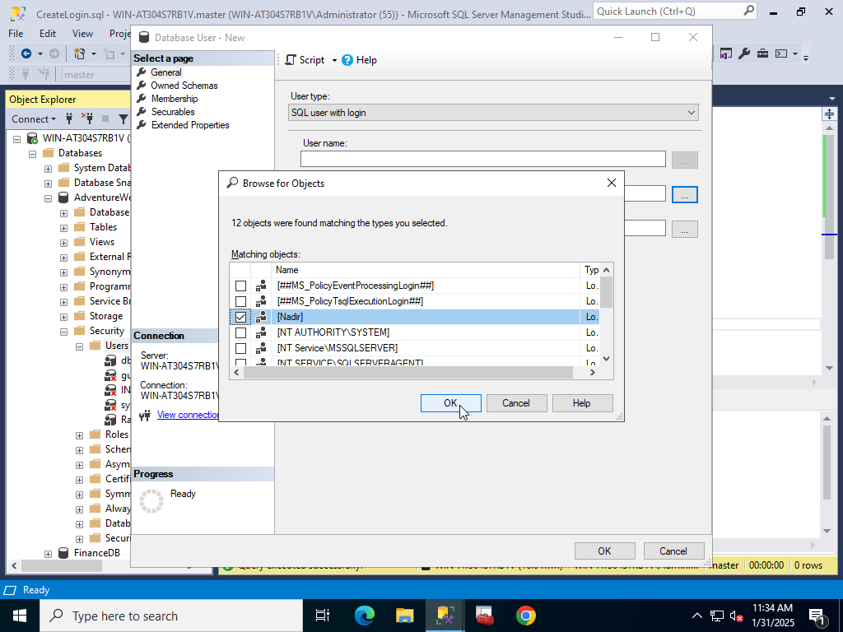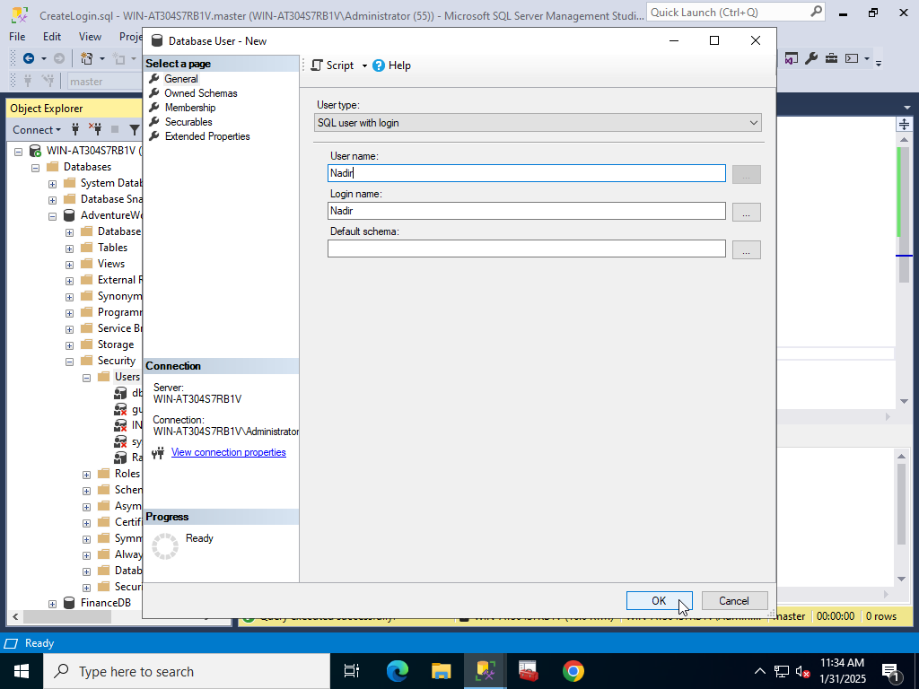

**4) Then I gave SELECT permissions for both of them to tables HumanResources.Department HumanResources.Employee only:**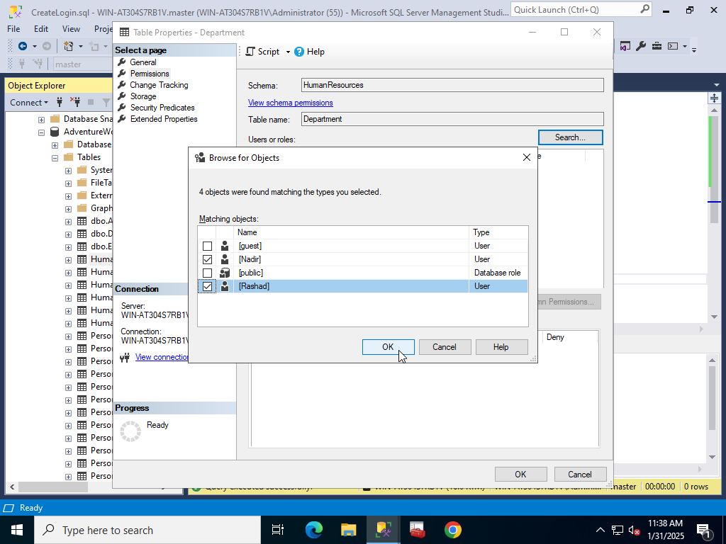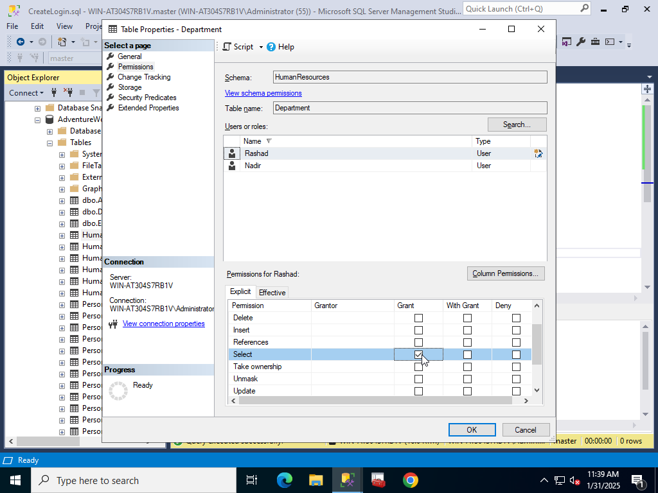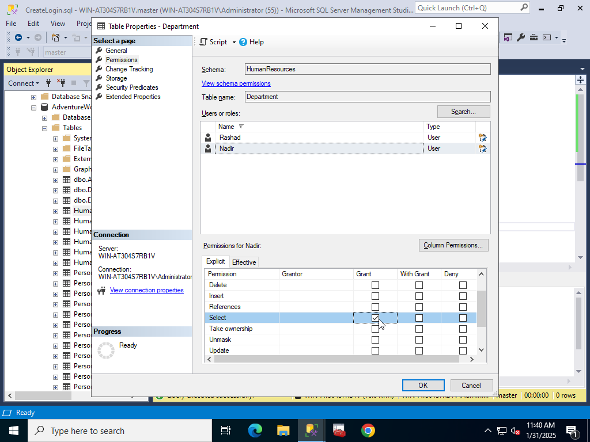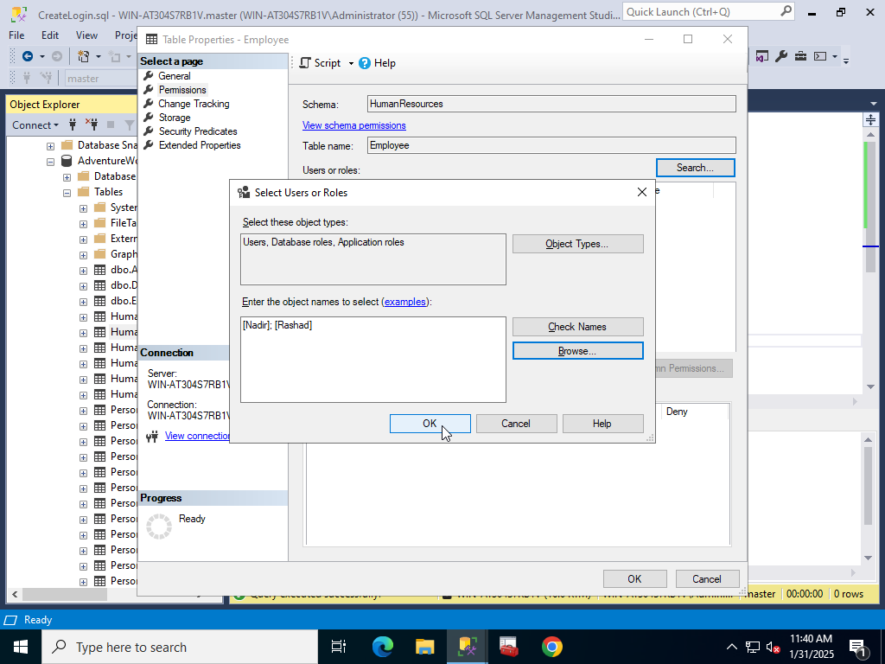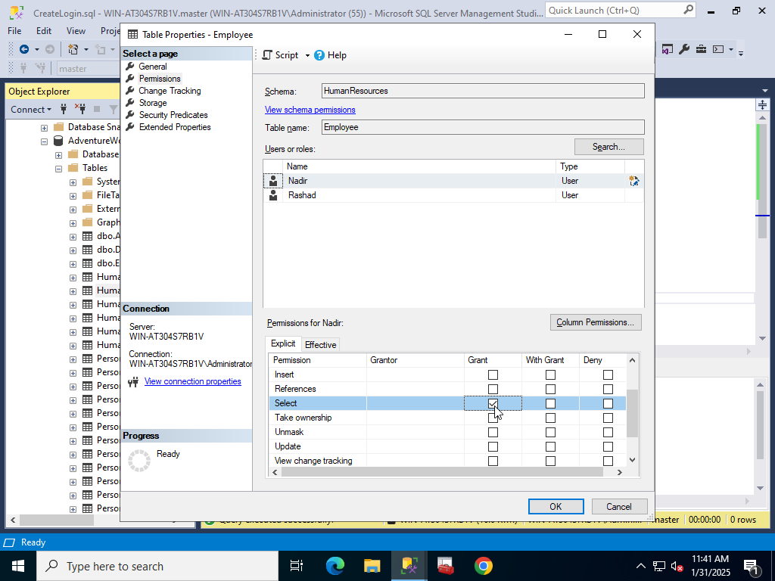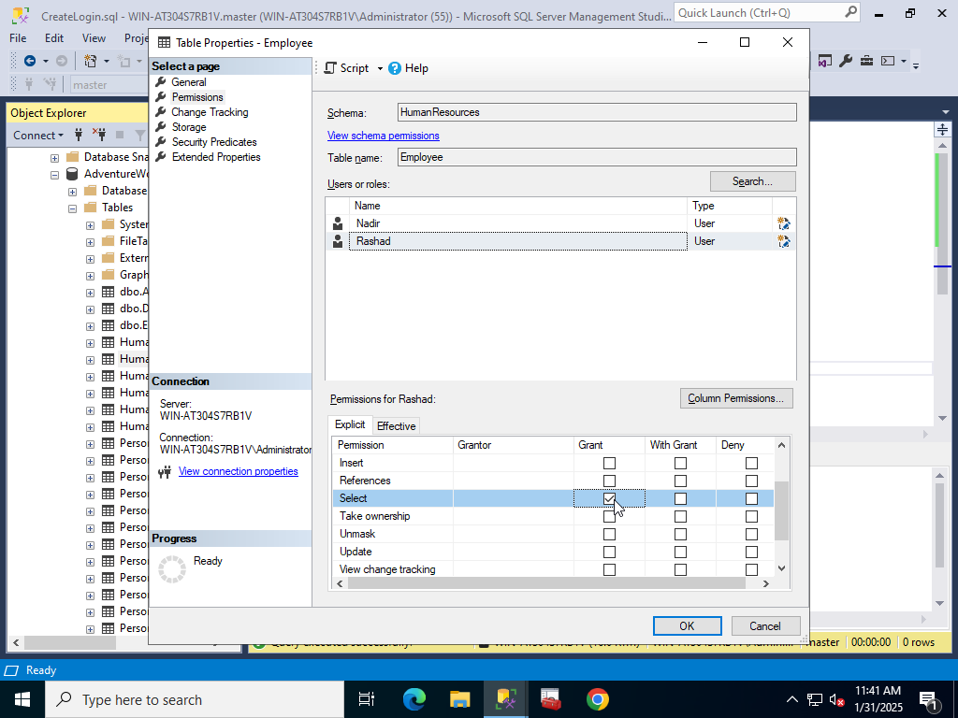

**5) Then I logged in as Nadir and Rashad to see if everything is okay or not :**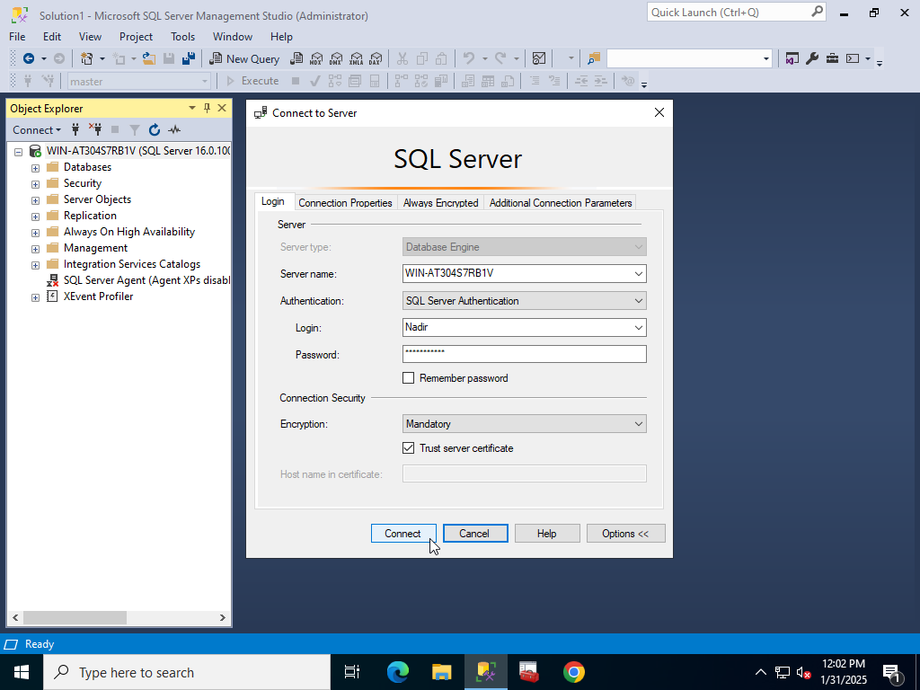

**6) And as you can see it says me to change password and I changed it “Password456” and clicked OK:**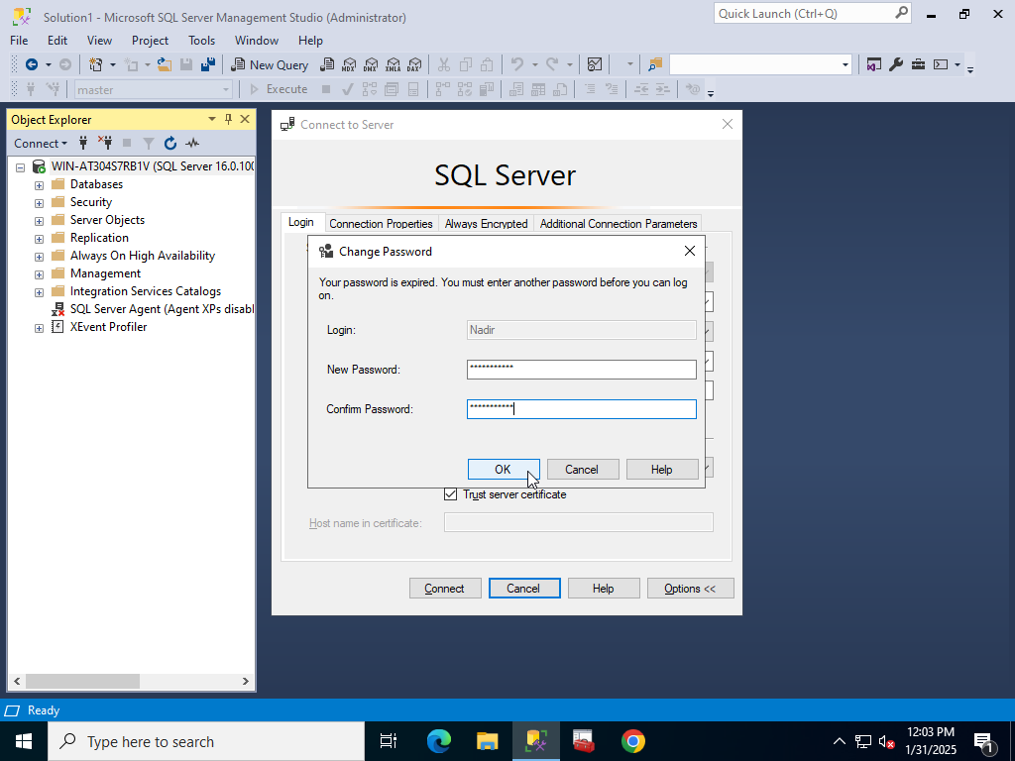

**7) I can see all databases because I have SQL Login but only have SELECT permissions 2 tables of AdventureWorks2014 because of SQL User has those permissions so I just see those 2 tables and I can only view them by selecting, I tried to delete these tables and expand other databases but it gave me error because I don’t have permissions:**